1_1 What is Graph
- Multiple edge
    - Tree – No
    - Graph-Yes
- Multiple way
    - Tree – No
    - Graph – Yes
- Cycle ( Most important )
    - Tree – No
    - Graph-Yes
- Edge direction
    - Tree – Yes ( p -> c )
    - Graph-No ( p -> c -> p )

1_2 Types of Graph :
- Direction:
  - Directed
  - Undirected
- Weight:
  - Weighted
  - Unweighted
- Cycle:
  - Cyclic
  - Acyclic

1_6 Input graph

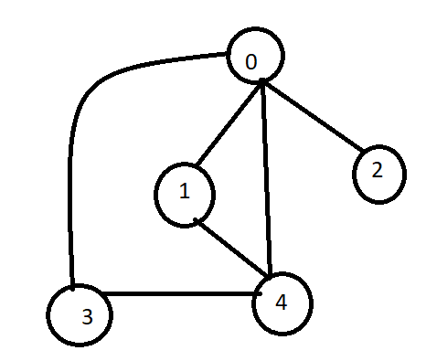

Node Edges
5 6
0 3
0 1
0 4
0 2
3 4
1 4

-Adjacency Matrix
-Adjecncy List
-Edge List

1_7 Adjacency Matrix

1_8 Adjacency Matrix Implementation
n e
5 5
0 1
0 2
3 0
1 3
3 4

adjacency_matrix_of_undirected_graph :

#include <bits/stdc++.h>
using namespace std;

int main()
{
int n, e;
cin >> n >> e;
int adj_mat[n][n];
// for (int i = 0; i < n; i++)
// {
// for (int j = 0; j < n; j++)
// {
// adj_mat[i][j] = 0;
// }
// }

// shortcut :
memset(adj_mat, 0, sizeof(adj_mat));

for (int i = 0; i < n; i++)
{
for(int j=0;j<n;j++){
if(i == j)
adj_mat [i][j] = 1;
}
}

for (int i = 0; i < e; i++)
{
int a, b;cin>>a>>b;
adj_mat[a][b] = 1;
adj_mat[b][a] = 1;
}

for (int i = 0; i < n; i++)
{
for (int j = 0; j < n; j++)
{
cout<<adj_mat[i][j]<<" " ;
}
cout<<endl;
}

return 0;
}

// input :
// 5 5
// 0 1
// 0 2
// 3 0
// 1 3
// 3 4

// output :
// 1 1 1 1 0
// 1 1 0 1 0
// 1 0 1 0 0
// 1 1 0 1 1
// 0 0 0 1 1

adjacency_matrix_of_directed_graph
#include <bits/stdc++.h>
using namespace std;

int main()
{
int n, e;
cin >> n >> e;
int adj_mat[n][n];
// for (int i = 0; i < n; i++)
// {
// for (int j = 0; j < n; j++)
// {
// adj_mat[i][j] = 0;
// }
// }

// shortcut :
memset(adj_mat, 0, sizeof(adj_mat));

for (int i = 0; i < n; i++)
{
for(int j=0;j<n;j++){
if(i == j)
adj_mat [i][j] = 1;
}
}

for (int i = 0; i < e; i++)
{
int a, b;cin>>a>>b;
adj_mat[a][b] = 1;
}

for (int i = 0; i < n; i++)
{
for (int j = 0; j < n; j++)
{
cout<<adj_mat[i][j]<<" " ;
}
cout<<endl;
}

return 0;
}

// input :
// 5 5
// 0 1
// 0 2
// 3 0
// 1 3
// 3 4

// output :
// 1 1 1 0 0
// 0 1 0 1 0
// 0 0 1 0 0
// 1 0 0 1 1
// 0 0 0 0 1

Extra Practice Problem (Optional):

Write adjacency matrix representations for the following graph:
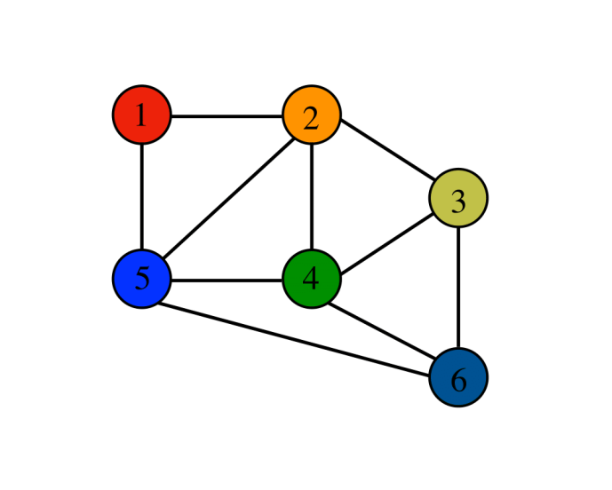

n e
6 10
1 2
1 5
2 4
2 5
5 4
2 3
4 3
3 6
5 6
4 6

#include<bits/stdc++.h>
using namespace std;

int main(){
int n, e;cin>>n>>e;
int adj_mat [n+1][n+1];

memset(adj_mat, 0, sizeof(adj_mat));

for (int i = 1; i <= n; i++)
{
for(int j=1; j<=n ; j++){
if(i == j)
adj_mat [i][j] = 1;
}
}

while (e--)
{
int a, b;cin>>a>>b;
adj_mat[a][b] = 1;
adj_mat[b][a] = 1;
}

for (int i = 1; i <= n; i++)
{
for(int j=1; j<=n ; j++){
cout<<adj_mat [i][j] << " ";
}cout<<endl;
}

return 0;
}

// input:
// 6 10
// 1 2
// 1 5
// 2 4
// 2 5
// 5 4
// 2 3
// 4 3
// 4 6
// 3 6
// 5 6

// output
// 1 1 0 0 1 0
// 1 1 1 1 1 0
// 0 1 1 1 0 1
// 0 1 1 1 1 1
// 1 1 0 1 1 1
// 0 0 1 1 1 1

